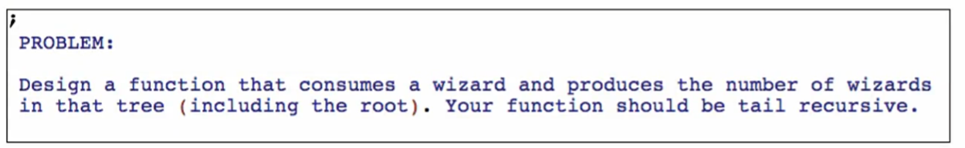

**Function definition**

**Signature, purpose, stub and example**

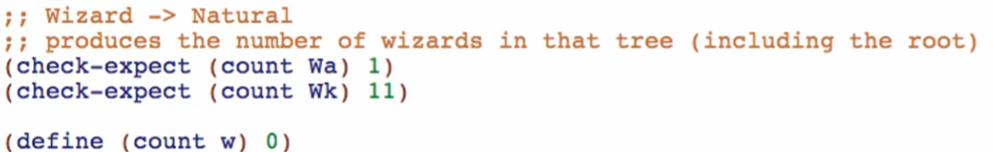

**Template**

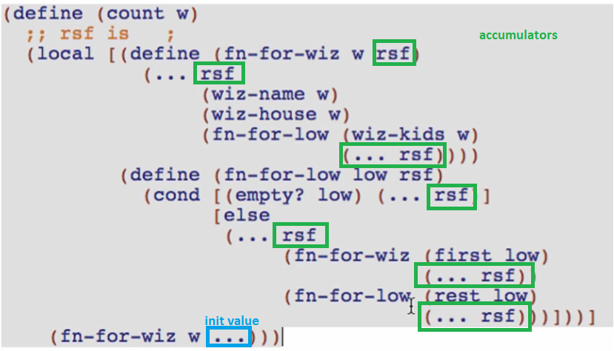

**Accumulator definition**

*Type*



*Signature*



*Examples*

We can write examples in the code:

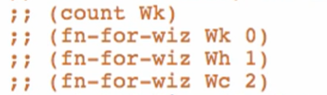

Or we can write them out in a picture:

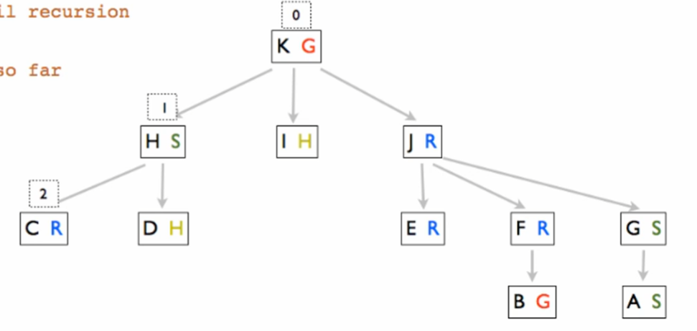

**Code body**

Initial value

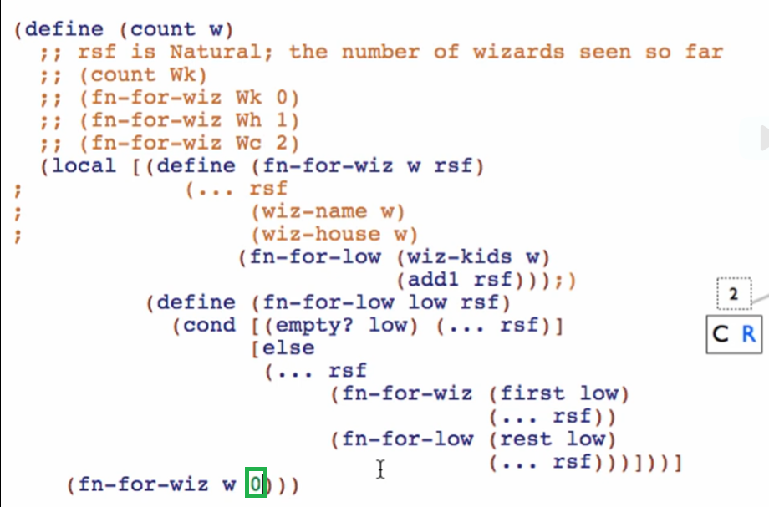

For fn-for-wiz

We want to achieve tail recursion but here’s a mutually recursive call that isn’t in a tail position

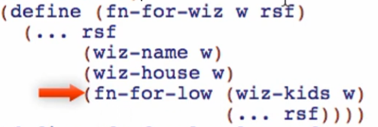

So we need to get rid of those stuff and make it in the tail position

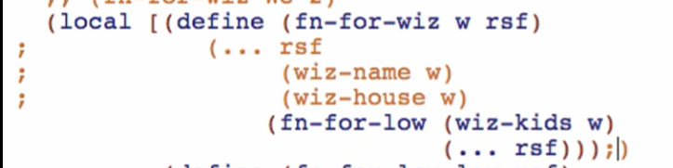

Note: For tail recursion in mutually recursive function, EACH mutually recursive call MUST be in TAIL position

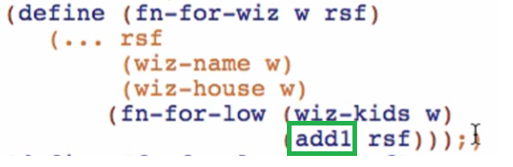

For fn-for-low

Note: usually in mutually recursive function with accumulators, only **ONE** of them change the value of the accumulator NOT all of them

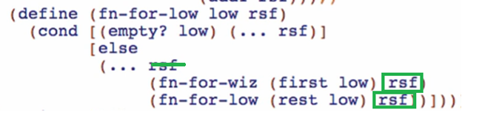

This isn’t right yet because it’s NOT tail recursion yet

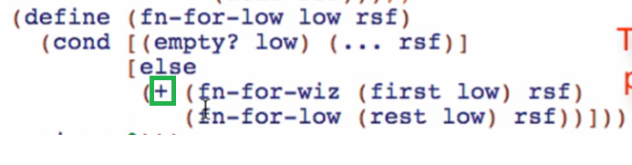

When there are no more elements in the list, we’ll return the accumulated number

